## THE SCIENCE BEHIND THE EDU-TAB- ‘Unlocking New pathways to learning’

Children love to play and once Learning is “Gamified” (turned into a game ) where the child plays a Maths game or English game, the brain opens up to learning naturally by releasing the hormones below,

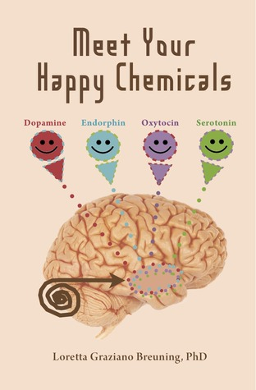

**These hormones open up the mind to enjoyment , excitement, bonding , trust and above all new learning!**

At the TOD Idea , our aim is to improve the brain the child brings to class. Rather than focus on the curriculum, the Edutab seeks to turn your child into a better learner by enhancing each child’s neural capacities and motivation for life long learning!

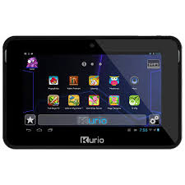

Through multi-sensory stimulation using the EduTab, we can develop certain neurological capabilities of your child that improve educational outcomes. Capabilities like;

1- Attention: The ability to focus on something despite the disrupting environment

2- Memory: Ability to remember episodes (Episodal Memory) and facts (Declarative Memory)

3- Processing: Speed at which the child gathers information, sequences it and stores it.

4-Spatial: The ability of the child to compare and contrast between things and situations

5- Predictive : This is ability of the child to anticipate what’s coming next.

6- Executive functions: These are decision making, planning, inhibitory control, preparation etc

The above neurological skill-set is what is required by your child to able to Compete, Collaborate and Create in the 21st century.

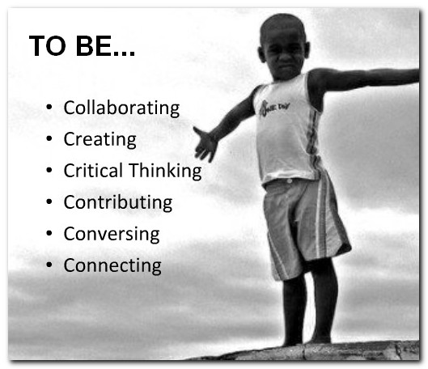

To Compete, Collaborate and Create are the core skills required to thrive in business and employment in the 21st century and the EduTab sets your child up for the challenge.

Are you Ready???

**COST**: 500,000/= Includes Apps, Video Tutorials and e-books, Free Leather Jacket and Free 8GB memory card.

Call 0757112376